Industrial Mini PC
QY-B5300-3
Small Size Series

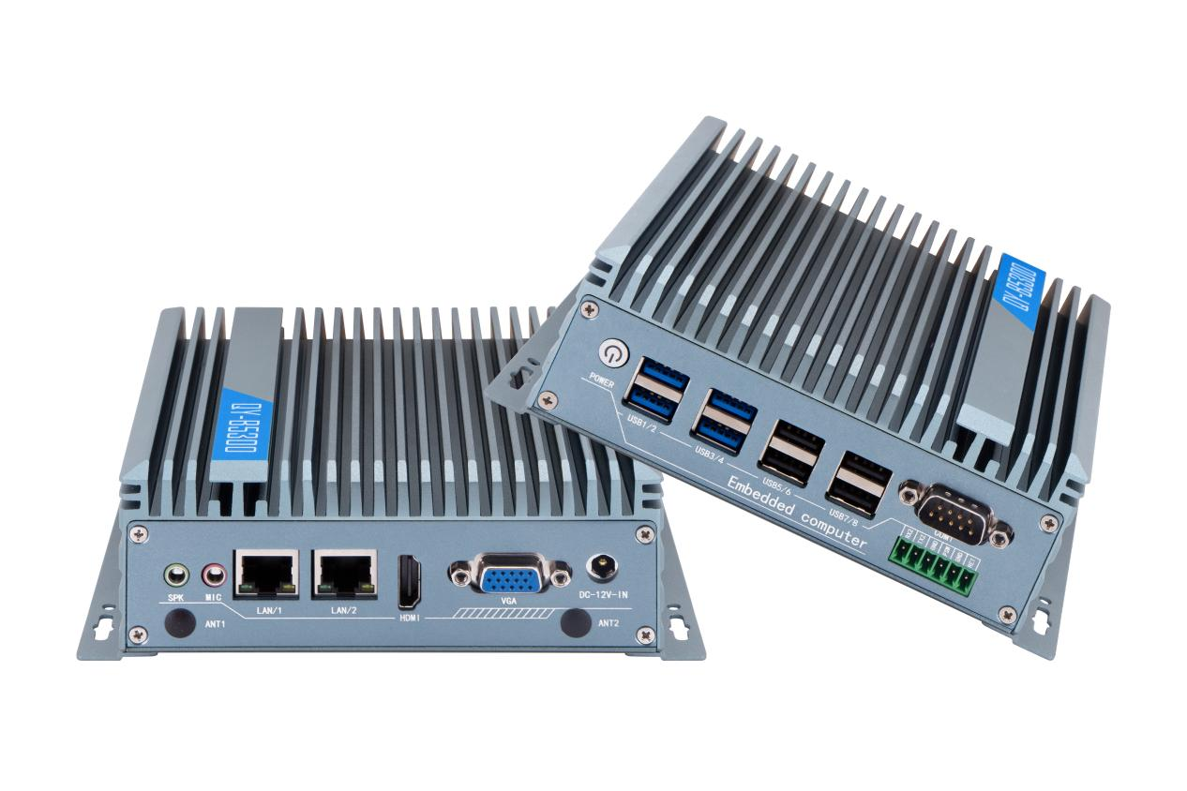
Products Features:
- Industrial-Grade Embedded Fanless Mini PC
- Intel Celeron / Atom and Core 4/5/6/7/8/10/12/13th-i3 / i5 / i7 CPU
- 2*LAN, 8*USB, 2*COM, 1*HDMI, 1*VGA
- 1*Mini PCIE Expansion Slot, Support 4G and WIFI Module
- Support Optional Fan Design Chassis
- DC 12V Power Input
- -20℃~60℃ Temperature Can Keep 24/7 Work Stably

QY-B5300-3
1.Mother Board Specification:
Model | QY-B5300-3
CPU | i3: 6157U / 7020U  i5: 7287U | i3: 8310U / 10110U  i5: 8350U / 10310U / 1135G7  i7: 8650U / 10610U / 1195G7 | i3: 1215U  i5: 1235U  i7: 1280P / 1355U
Memory^{[1]} | 1*DDR IIII RAM Slot, Up to 16GB | 2*DDR IIII RAM Slots, Up to 32GB | 1*DDR V RAM,Slot, Up to 48GB
Storage | 1*M.2 NVME Slot  1*SATA SSD Slot
Display | 1*HDMI: Resolution up to 4096*2160@60Hz  1*VGA: Resolution up to 1920*1200@60Hz
Expansion | 1*Mini PCIE Slot, Support 4G and WIFI module
Ethernet | 2*Realtek 8111E LAN Chip (10 / 100 / 1000 Mbps, RJ-45 Type)
USB | 4*USB 3.0 (Type-A)  4*USB 2.0 (Type-A)
COM | 1*RS-232 (DB9 Type)  1*RS-232 (Phoenix Terminal Type)
Audio | 1*Line-Out

QY-B5300-3
2.Device Specification:
Power Input | DC 12V
Power Input | Support Auto-Start
Power Input | 1*2.5mm Circle Type DC Plug
Working Temperature | -20℃~60℃, Support 24/7 Working
Structure | Fully Enclosed Aluminum Alloy Material
Heat Dissipation | Fanless Design, Conduction Heat Dissipation
Heat Dissipation | Fan design Chassis (optional)
Installation | Desktop / Embedded / Wall Mount
Size | 159.6mm*127mm*53mm
System | Windows and Linux

QY-B5300-3
3.Ordering Information:
Model | CPU | LAN | USB | COM | Display | RAM | SSD | Expansion | Power
QY-B5300-1 | N2840 / J1900  4th / 5th | 2 | 6 | 2*RS-232 | 1*HDMI  1*VGA | 1*DDR 3  Up to 8GB | 1*MSATA  1*SATA | 1*Mini PCIE | DC 12V
QY-B5300-2 | J6412 | 2 | 4 | 2*RS-232/485 | 2*HDMI  1*DP | 1*DDR 4  Up to 16GB | 1*MSATA  1*SATA | 2*Mini PCIE | DC 12V
QY-B5300-2 | N95 / N100 |  |  |  |  |  | 1*M.2 NVME  1*SATA | 2*M.2 | DC 12V
QY-B5300-3 | 6th / 7th | 2 | 8 | 2*RS-232 | 1*HDMI  1*VGA | 1*DDR 4  UP to 16GB | 1*M.2 NVME  1*SATA | 1*Mini PCIE | DC 12V
QY-B5300-3 | 8th / 10th |  |  |  |  | 2*DDR 4  UP to 32GB | 1*M.2 NVME  1*SATA | 1*Mini PCIE | DC 12V
QY-B5300-3 | 11th / 12th / 13th |  |  |  |  | 1*DDR 5  Up to 32GB | 1*M.2 NVME  1*SATA | 1*Mini PCIE | DC 12V
QY-B5300-4E | J6412 | 4 | 6 | 2*RS-232 | 1*HDMI  1*DP | 1*DDR 4  Up to 16GB | 1*M.2 NVME  1*SATA | 1*Mini PCIE  1*M.2 | DC 12V
QY-B5300-4E | N100 |  |  |  |  |  | 1*MSATA  1*SATA | 1*M.2 | DC 12V
QY-B5300-6C | J6412 | 2 | 4 | 2*RS-232/485  4*RS-232 | 2*HDMI  1*DP | 1*DDR 4  Up to 16GB | 1*MSATA  1*SATA | 2*Mini PCIE | DC 9-36V
QY-B5300-6C | N95 / N100 |  |  |  |  |  | 1*M.2 NVME  1*SATA | 2*M.2 | DC 9-36V

QY-B5300-3
4.CPU Information:
CPU | Specification
i3-6157U | 2 core, 4 total threads, 2.40 GHz, 3 MB cache | Max to 16GB for 1*RAM 4 slot
i3-7020U | 2 core, 4 total threads, 2.30 GHz, 3 MB cache | Max to 16GB for 1*RAM 4 slot
i5-7287U | 2 core, 4 total threads, 3.30 GHz to 3.70 GHz, 4 MB cache | Max to 16GB for 1*RAM 4 slot
i3-8130U | 2 core, 4 total threads, 2.20 GHz to 3.40 GHz, 4 MB cache | Max to 32GB for 2*RAM 4 slots
i5-8350U | 4 core, 8 total threads, 1.70 GHz to 3.60 GHz, 6 MB cache | Max to 32GB for 2*RAM 4 slots
i7-8650U | 4 core, 8 total threads, 1.90 GHz to 4.20 GHz, 8 MB cache | Max to 32GB for 2*RAM 4 slots
i3-10110U | 2 core, 4 total threads, 2.10 GHz to 4.10 GHz, 4 MB cache | Max to 32GB for 2*RAM 4 slots
i5-10310U | 4 core, 8 total threads, 1.70 GHz to 4.40 GHz, 6 MB cache | Max to 32GB for 2*RAM 4 slots
i7-10610U | 6 core, 12 total threads, 1.80 GHz to 4.70 GHz, 12 MB cache | Max to 32GB for 2*RAM 4 slots
i5-1135G7 | 4 core, 8 total threads, 4.20 GHz, 8 MB cache | Max to 64GB for 2*RAM 4 slots
i7-1195G7 | 4 core, 8 total threads, 5.00 GHz, 12 MB cache | Max to 64GB for 2*RAM 4 slots
i3-1215U | 6 core, 8 total threads, 3.30 GHz to 4.40 GHz, 10 MB cache | Max to 32GB for 1*RAM 5 slot
i5-1235U | 10 core, 12 total threads, 3.30 GHz to 4.40 GHz, 12 MB cache | Max to 32GB for 1*RAM 5 slot
i7-1280P | 14 core, 20 total threads, 3.60 GHz to 4.80GHz, 24 MB cache | Max to 32GB for 1*RAM 5 slot
i7-1355U | 10 core, 12 total threads, 3.70 GHz to 5.00GHz, 12 MB cache | Max to 48GB for 1*RAM 5 slot

5.System Information:

CPU | System
6th / 7th | Windows 7 / 10 and Linux
8th / 10th / 12th / 13th | Windows 10 / 11 and Linux
QY-B5300-3
6.Fittings Information:
RAM | DDR 4 | 4GB / 8GB / 16GB / 32GB
RAM | DDR 5 | 4GB / 8GB / 16GB / 32GB / 48GB
Storage | M.2 NVME | 128GB / 256GB / 512GB / 1TB / 2TB / 4TB
Storage | SATA | 120GB / 128GB / 240GB / 256GB / 480GB / 512GB / 960GB / 1TB / 2TB / 4TB
GSM Module | 4G | 4G+GPS
WIFI Module | 7260AC / AX210

7.Package List:

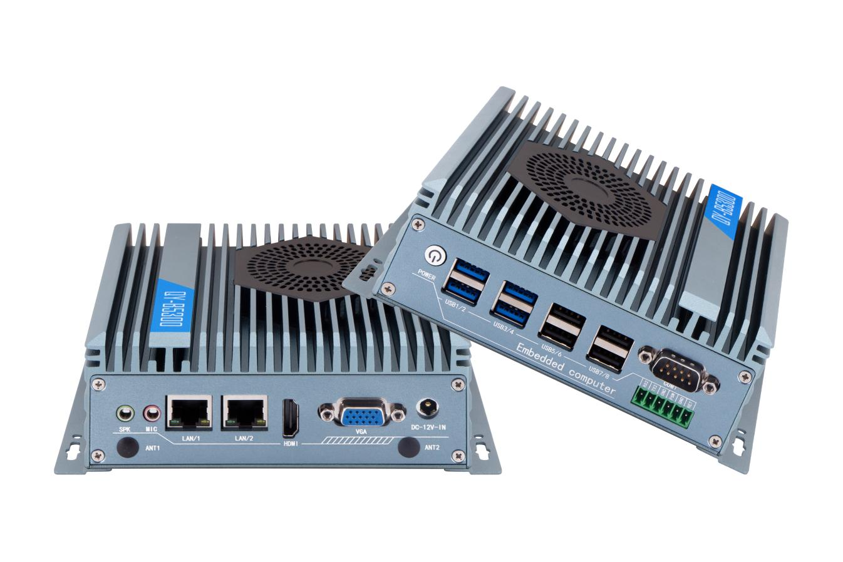
Adapter | 1*12V 5A Adapter
Power Cable | 1*Power Cable

8.Fan Design Chassis:

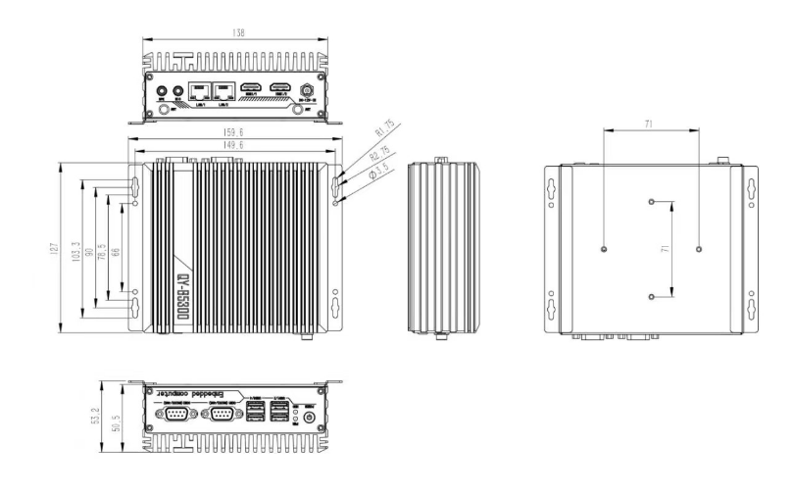
9.Dimensions:
QY-B5300

